How to Return Our Customers 15% Memory and Speed Up Full Sync by Up to 70×

Why are you reading this?
We need a better full sync mechanism. The current approaches — BGSAVE and ThreadSave — have fundamental limitations that cost us memory, availability, and customer trust:
- Memory waste: BGSAVE requires 25% COW headroom reserved.
- Customer experience - We measure user experience by three categories:
  - Duration — The duration of the current save methods is long, we will show up to 70x improvement. Why does this matter?
    - For users reading from replicas, this is downtime or elevated latency during failure recovery clients fall back to other nodes which may get overloaded.
    - Increase the chances of dataloss for multi-node failure.
    - For serverless — this is the migration time for DMS and can be used for replica scale out in the future.
  - Latency during full sync — the impact on active traffic while SAVE is running. We will show freeze time during BGSAVE and limitations of ThreadSave that cause elevated latency.
  - Sync failures - From data collected from the last 30 days in us-east-1 over valkey versions 8+, 37% of the sync socket operations failed, where threadSave is the main factor. out of 52K threadSave sync socket operation 58.5% failed. Out of 30K BGSave sync socket operations 1% failed. Disk operations and snapshots operations works much better. See Appendix D: Save operational issues. However, relying on BGSave as the main save mechanism is operational risk, In grav4 we are going to reduce the reserved memory by 16% for large instances and by 6%-14% to smaller one, see proposal. Less reserved memory reduce BGSave robustness.
  - OPS - Replication issues are still about 8% of all SEV2 in provision. See Appendix F. Replication related sev2s in ElastiCache

We propose a new primary sync method and define tenets to guide the evaluation.

Tenets — How we choose the best full sync method (in priority order)
- Cost —
  - Memory: Memory is the largest cost contributor for an in-memory database. Recent DRAM price increases (up to 400% in the past two quarters) make engine memory efficiency a direct lever on operational cost.
  - CPU: As we dedicate more cores to steady-state request processing (io-threads) and have future plans to increase CPU usage (3M TPS), sync mechanisms should minimize core usage for an operation that happens infrequently.
- Minimize customer-visible latency and downtime — The best sync is one the customer doesn't notice. Minimal p50 and p99 impact during save with minimal downtime.
- Robustness — Must work reliably across all workloads, data types, and modules (including VSS, streams, and large objects).
- Speed of sync — Faster sync means shorter replica unavailability, reduced availability risk, and reduced data loss window.

Proposed solution
- Deprecate BGSAVE. Use DollySave (CRIU-based) as primary sync, ThreadSave as fallback for environments that cannot support DollySave.
- Reduce the default reserved-memory to 10% and save 15% to our customers.

Why 15% memory saving is significant?
Over the past two years, Valkey 8.0 and 8.1 delivered per-key overhead reductions (20% and 27% respectively) by embedding keys, replacing the hash table, and consolidating allocations. But these save a fixed 32 bytes per key — for 512B+ values, gains are minimal (4% for 512B, 2% for 1KB, negligible for 8KB or VSS indexes).

As seen in Appendix C, the Valkey 8.x changes save more than ~2% for only 20% of instances, and ~4% for less than 10%. We saved 15%+ for only 3% of customers. The 15% COW headroom is different — it scales with total dataset size regardless of value size. No per-key optimization can reclaim it. Only eliminating COW itself addresses that.

What you are about to see?
DollySave outperforms BGSAVE in every tested scenario and has pros and cons vs ThreadSave that are discussed below. Both DollySave and ThreadSave eliminate OOM entirely. A combined approach — DollySave as primary, ThreadSave as fallback — is proposed.

Benchmark setup for scenarios 1 to 4
- Instance: r7g.16xlarge (64 vCPU, 512 GB RAM)
- Dataset: 450M keys × 512 bytes ≈ 300 GB
- Server: Valkey 8.2. - amz_valkey_release:R5
- Compression ratio: 70% savings
The benchmark measures the time till the replica is fully synced, including the delta.

Scenario 1 - no traffic:
Purpose: Establish a baseline with no background load
 | BGSave | Dolly | ThreadSave
Duration (seconds) | 1102.31 | 20.92(52x) | 1144
Extra memory usage in GB | 2.28 | less than 0.1 | less than 0.1
Downtime in ms (process freeze) | 4207 | 233 | 0
Takeaway: On an idle server, the best case for BGSAVE, it still takes 18 minutes. DollySave completes in 21 seconds. ThreadSave is similar in duration to BGSAVE but uses no extra memory and no process freeze time.
The process freeze time of BGSave is since during fork the kernel iterates over all pages.

Scenario 2 - GET heavy:
Purpose: Test read-heavy workload performance.
Traffic:
- 400K GET/s
- 1.5K SET/s
 | BGSave | Dolly | ThreadSave
Duration (seconds) | 1084 | 21.70 (52x-55x) | 1203
Extra memory usage in GB | 24.047 | less than 0.1 | less than 0.1
Downtime in ms (process freeze) | 4173 | 1216 | 0
The chart below shows p50 and p99 latency recovery after SAVE (excluding the freeze time). DollySave (blue) recovers in ~3 seconds; BGSAVE (red) takes ~19 seconds (excluding the fork time of 4.1 seconds).
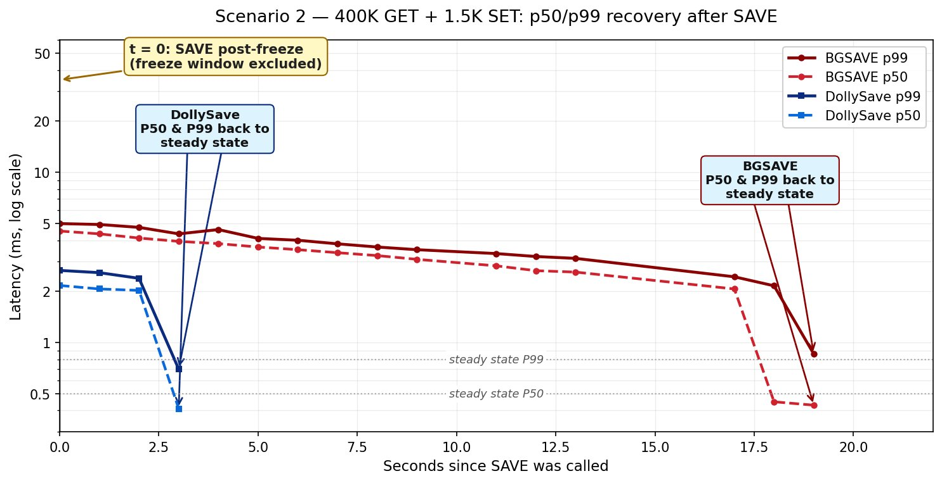
Takeaway: Under read-heavy load, BGSAVE's COW jumps to 24 GB and latency stays elevated for ~19 seconds. DollySave recovers in 3 seconds. ThreadSave has no latency impact in this scenario but takes 20 minutes ,same as BGSave.

Scenario 3 - Mixed Traffic (400K GET + 100K SET)
Purpose: Test under realistic mixed read/write load.
Traffic:
- 400K GET/s
- 100K SET/s
 | BGSave | Dolly | ThreadSave
Duration (seconds) | (OOM) | 22.45 (58x) | 1313
Extra memory usage in GB | 200 | less than 0.15 | less than 0.1
Downtime in ms (process freeze) | 8346 | 1736 | 0
The chart below shows DollySave (blue) recovering in ~4 seconds while BGSAVE (red) takes ~49 seconds (excluding the fork time of 8.3 seconds):
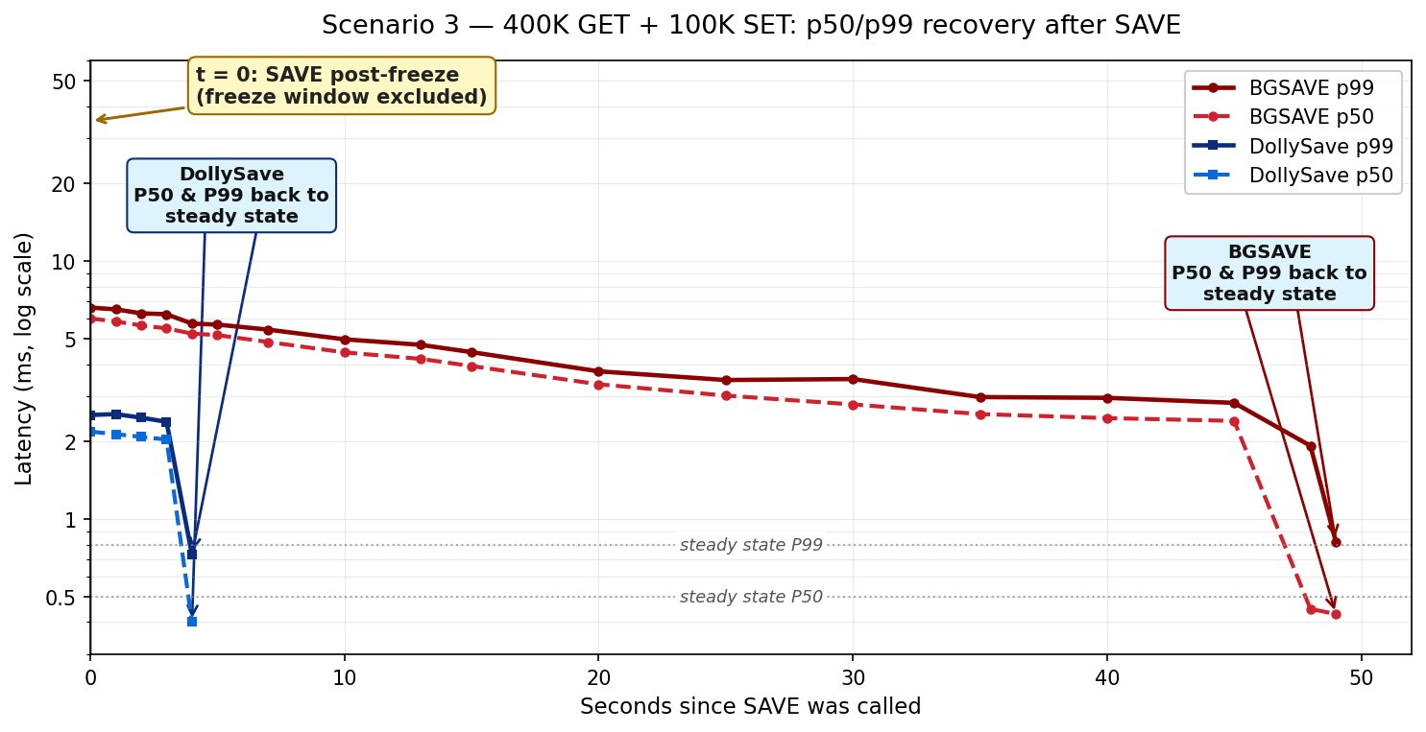
The chart below shows ThreadSave's sustained latency elevation (p50 at 2.8 ms, p99 at 5–7 ms) for the full 1313-second save. It shows that thread save has impact on the main thread under heavy usage scenarios.
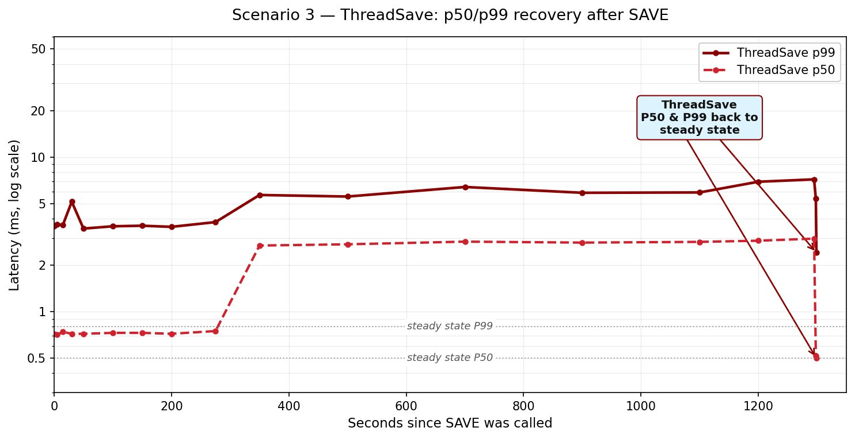
Takeaway: This is where BGSAVE breaks it consumed ~200 GB of COW and OOM'd. DollySave completed in 22.5 seconds with 144 MB overhead and no latency impact. ThreadSave avoids OOM but keeps p50 elevated at 3 ms and the replica disconnected for the full 22-minute save due to the cron job running on the main thread that feed the threadSave with data.

Scenario 4 - MSET Batched Writes:
Purpose: Test performance with batched writes (MSET of 20 keys per command).
Traffic:
- 400K GET/s
- 100K SET ops/s via MSET(20)
 | BGSave | Dolly | ThreadSave
Duration (seconds) | (OOM) | 24.61 (71x) | 1747
Extra memory usage in GB | 200 | less than 0.15 | less than 0.1
Downtime in ms (process freeze) | 9564 | 1950 | 0
The chart below shows DollySave (blue) with immediate recovery while BGSAVE (red) takes ~37 seconds to recover:
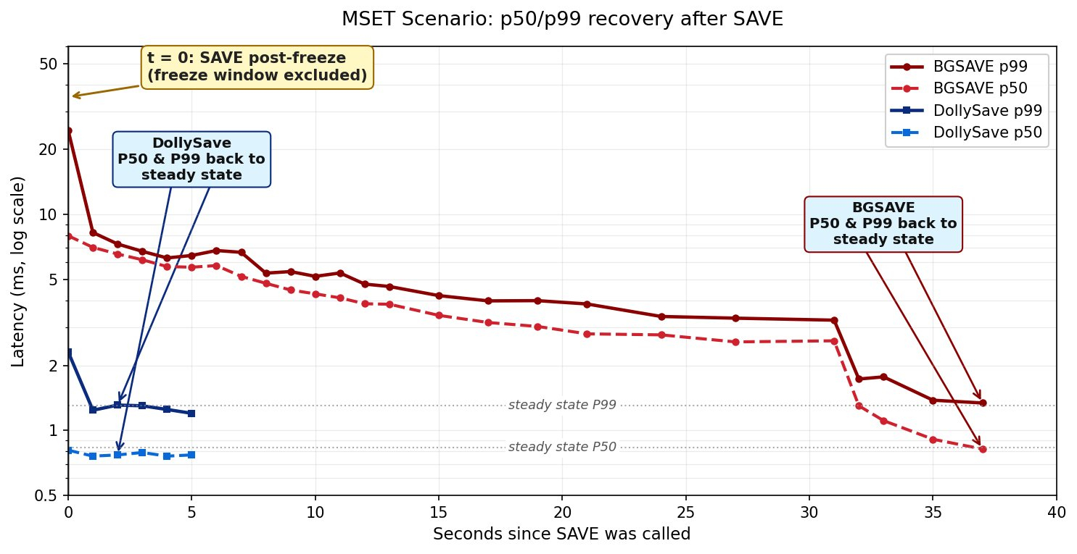
The chart below shows ThreadSave's p50 ramping to 6–11 ms and P99 12-15 ms and sustaining for ~1747 seconds:
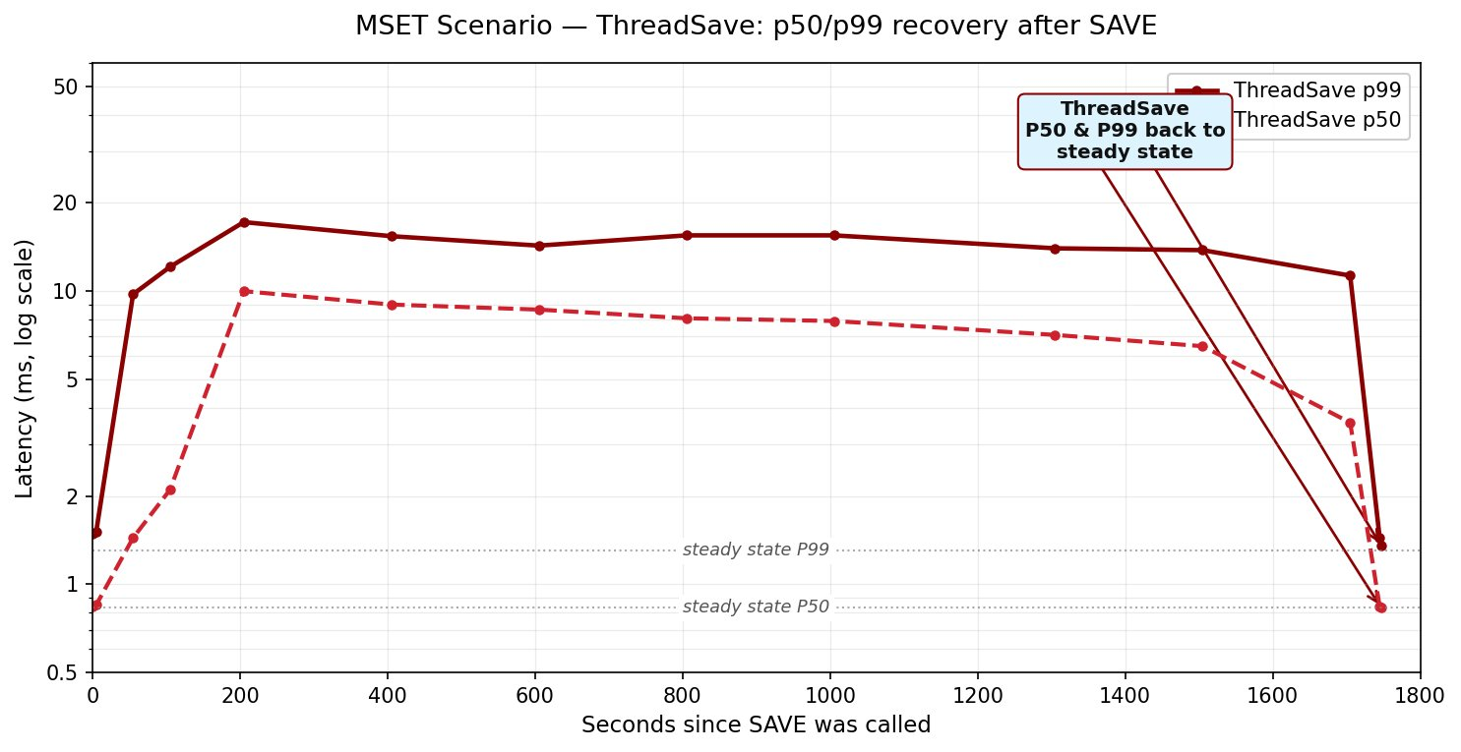
Takeaway: Under the MSET tested (~405K server TPS), BGSAVE OOM'd again. DollySave had minor latency impact and finished in 25 seconds. ThreadSave sustained p50 at 6–11 ms and high P99 latency for nearly 30 minutes showing MSET requires blocking the clients.

Scenario 5 - Large data types:
Warmup — Populates all 3,000 hash tables 100MB each, value size 512 bytes.
unlike prev scenarios data is non compressible.
Benchmark:
- 140K HGET/s — random reads
- 20K HSET/s — random field updates with fresh data.
The benchmark pipeline the commands which causes head of the line blocking, this is the worst case scenario for threadsave.
 | BGSave | Dolly | ThreadSave
Duration (seconds) | 878 | 42.2 (20x) | 836
Extra memory usage in GB | 102 | less than 0.1 | less than 0.1
Downtime in ms (process freeze) | 10256 | 450 | 0
The chart below shows DollySave completing in 42 seconds with only a p99 elevation due to the high network load — p50 is unaffected:
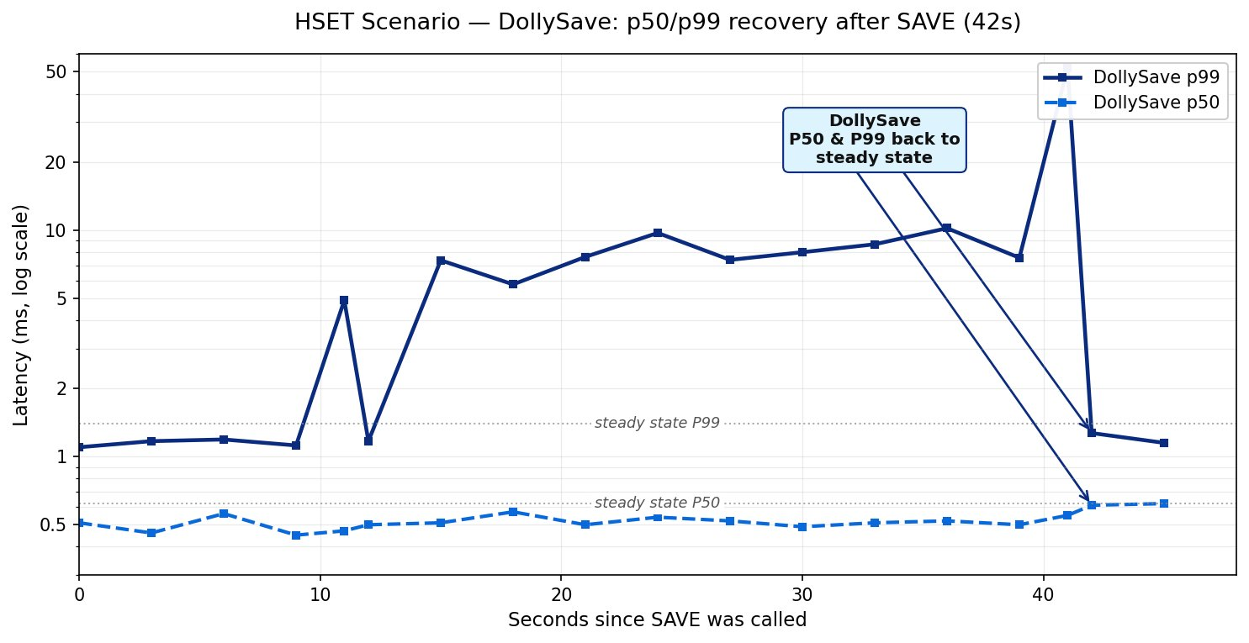
The chart below shows ThreadSave pinning both p50 and p99 at the 50 ms client timeout for the entire 836-second save:
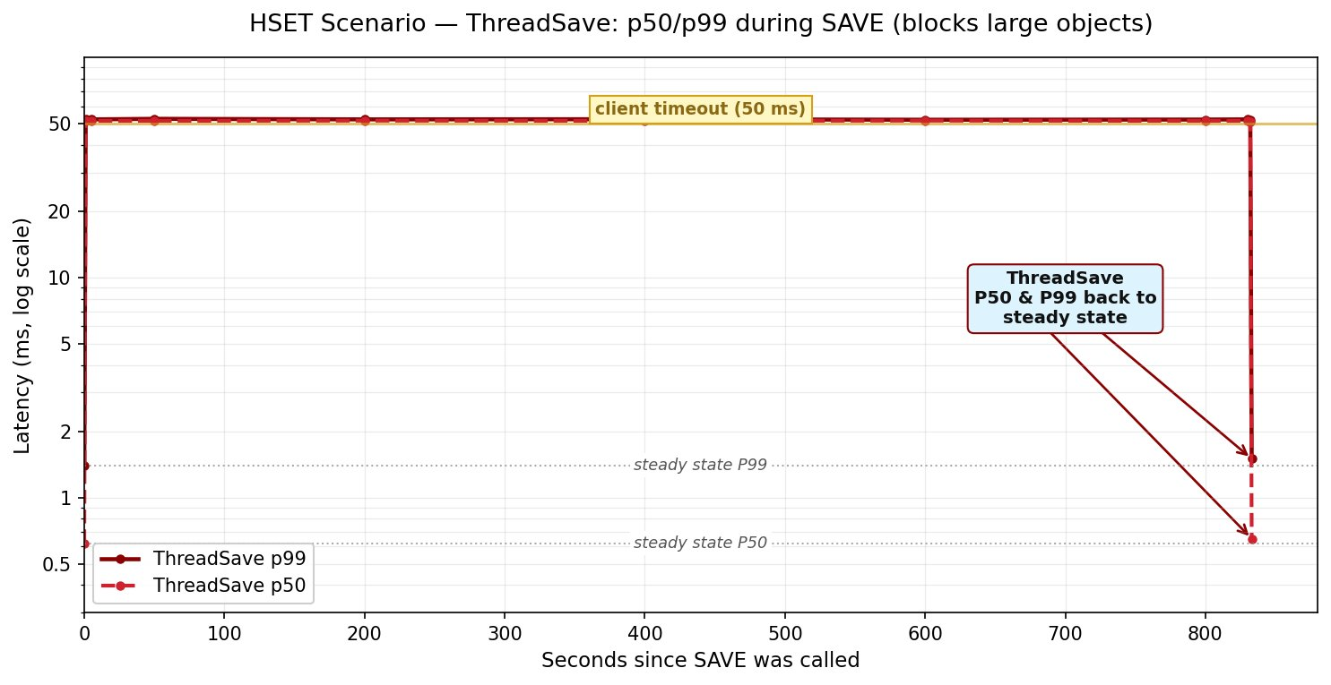
Takeaway: This is where ThreadSave fails. It locks large objects during serialization, pushing p50 and p99 to the client timeout (50 ms) for the entire 836-second save — effectively a service outage for HSET commands. BGSAVE has no latency impact here but consumes 102 GB of COW. DollySave has latency impact on P99, mainly since we consume more network as the data is non compressible unlike the prev scenarios.

Scenario 6 - small instance - no traffic:
A fair skeptic at this point says: "You're beating BGSAVE because you've thrown more threads at it. Hold parallelism constant and the advantage disappears."
So we ran Scenario 6 on a smaller r7g.xlarge with a single sender thread and 220 million small keys (50 B each) - only 23GB, different shape.
 | BGSave | Dolly | ThreadSave
Duration (seconds) | 149.678 | 20.46(7x) | 154
Extra memory usage in GB | 0.149 | less than 0.05 | less than 0.05
Downtime in ms (process freeze) | 329 | 85 | 0
Even single-threaded, with none of the parallel-sender machinery engaged, DollySave is 7× faster than BGSAVE. The advantage isn't coming only from threads it's coming also from the fact that we send raw memory with no serialization. DollySave avoids object serialization entirely by streaming raw memory, which removes a major CPU and latency component inherent in RDB generation. We have not tested complex objects that may increase the duration gap even further.

DollySave Limitations
- DollySave requires identical binaries and kernel version on source and target. The process image is a raw memory snapshot — it cannot be restored on a different Valkey version or a different kernel version. This means DollySave cannot be used directly for version upgrades (a two-phase approach is needed) + updates to our MP/CP workflows.
  - Snapshots - For snapshots we will have either have to save the process in Dolly format or have 2 phase approach
  - Upgrade - Two phase approach is needed. See upgrade section below
- DollySave requires Linux kernel ≥ 6.7. Older kernels do not support the userfaultfd write-protect async features that DollySave depends on. That is, we will have to update the kernel.
- Huge pages - Like BGSave, DollySave struggle with huge pages as it have to transfer more data on writing to pages.

Why ThreadSave is fallback only
It solves OOM but:
- p50 elevated 3–14× for 1200–1747 seconds at the examples above.
- Completely blocks large objects, as seen in Appendix C: Value size at the fleet the P90 of the value size is 9.2MB. Serializing and compressing 9.2MB values take 50ms - 150ms, depends on the object type. This has direct impact on P99 latency or even P50 in random write scenarios with pipeline. We do not expect to see any latency impact on reads without pipeline.
  - Also seen at Scenario 5 - Large data types: 50 ms timeout for 836 seconds.
- Replica disconnected for long time as ThreadSave is slow.
- Multi-key commands (MSET, etc.)
ThreadSave serializes keys in order. To maintain consistency, if a write command touches a key that has already been transferred, ThreadSave must block the command until it can safely handle the conflict — otherwise the snapshot would be inconsistent. For multi-key commands like MSET (which writes 20 keys in a single call), the probability that at least one key has already been serialized grows with save progress. As the save advances, more and more keys fall into the "already transferred" set, making blocking increasingly likely. When this happens, the client is blocked until the conflict is resolved. This explains the sustained 6–11 ms p50 we observed in Scenario 4: it's not just contention with the key currently being serialized — it's contention with the entire set of already-transferred keys that grows throughout the save.
Commands that write to multiple keys: MSET, MSETNX, DEL, UNLINK, RENAME, RENAMENX, SMOVE, LMOVE, BLMOVE, RPOPLPUSH, BRPOPLPUSH, LMPOP, BLMPOP, MIGRATE, EVAL, EVALSHA, FCALL (All declared keys marked as writable)
Commands that write to one destination: COPY, SDIFFSTORE, SINTERSTORE, SUNIONSTORE, ZDIFFSTORE, ZINTERSTORE, ZUNIONSTORE, ZRANGESTORE, GEOSEARCHSTORE, PFMERGE , SORT...STORE
- VSS (Vector Similarity Search) and module aux-data
Modules with large auxiliary data (e.g., VSS Search indexes that can be GBs in size) cannot generate a point-in-time view iteratively. ThreadSave may still need to fall back to fork-based mechanisms for these modules. Module aux-data is whole-DB, not per-key. This is the killer. Vector indexes (VSS) store their state as module aux-data, not as keyspace entries. Threadsave's whole locking model is per-key — there's no concept of "the vector index is in-flight, block all VADD." Instead, rdbSaveModulesAux() runs on the main thread with serverAssert(onRedisMainThread()), blocking the entire event loop for the duration of aux serialization. For multi-GB VSS indexes this is seconds-to-minutes of total stall.
- Pipeline - pipelines is the recommended way for Valkey, clients like valkey-GLIDE, Lettuce, Redisson, valkey-py, SE.Redis and the node.js clients. All will get blocked on head of the line blocking if one of the keys is currently being serialized.
- For serverless we decided not to use threadsave - todo consult with Elad Bernstein

Why DollySave wins
- No OOM. less than 150 MB constant vs 2–200 GB. Eliminates the #1 reliability risk in SAVE.
- 20–71× faster. 18 min → 21–42 s. Faster scale-up, replica addition, failure recovery.
- Minimal p50 impact. Stays at steady state. BGSAVE: 18–48 s elevated. ThreadSave: 1200–1747 s elevated or timeout.
- 15–25% memory back. No COW headroom needed.
- Fast p99 recovery. vs 19–49 s (BGSAVE) vs full save duration (ThreadSave).

How DollySave works
No fork(). Live process migration:

- Track writes without copying. Kernel marks dirty pages via userfaultfd — no COW.
- Stream memory while serving. Parallel workers compress and send pages. Process keeps running.
- Brief final freeze. 233 ms – 1.95 s to capture last dirty pages. Then unfreeze.
Full design docs:
- High-level design: (https://asafpamzn.github.io/criu/cow-dump-high-level-design.html)
- Detailed design: (https://asafpamzn.github.io/criu/cow-dump-design.html)

What about Snapshots?
Today, ElastiCache creates snapshots using BGSAVE, stores them as RDB files in S3, and allows users to export them to their own S3 bucket. Users rely on this RDB format to seed new clusters, migrate across regions, or process data
offline with external Redis/Valkey tooling. This is a documented, contractual interface.

DollySave produces a raw process image, not an RDB file. Two approaches for snapshot compatibility:

Option 1 (preferred) — Background conversion (eager conversion)

Store snapshots in DollySave format, then a background fleet reads each snapshot from S3 and converts it to RDB asynchronously.
Pros:
- Same user experience as today — RDB files appear in S3 as they do now with a short delay.
- No change to export, restore, or cross-region workflows.
Cons:
- Requires a fleet of EC2 instances dedicated to conversion.
- Adds operational cost - we estimate the yearly cost
- The estimated yearly external cost per fleet of 11 PB as 843,150$
  - Based on the assumption that it takes 20 seconds to process 1GB of rdb and dollySave with using c7g. In practice it is much faster.

Option 2 — Convert to RDB on restore (lazy conversion)

Store snapshots in DollySave format. When the user requests a restore, spin up a temporary instance from the CRIU image and generate the RDB at that point.

Pros:
- Lower storage and compute cost — no background conversion fleet needed.
Cons:
- Breaks the existing user experience. Today, users can export snapshots to their own S3 bucket and get a standard RDB file immediately. With this approach, users who export would either get an unusable process image or face a conversion delay at export time. This changes a contractual interface.

What about upgrades and patching?

Today, on each engine crash or node failure we create an instance with the latest patch version, and on node failure with the latest kernel. This allows us to upgrade the fleet incrementally. With DollySave we cannot do this directly — it requires identical binaries on source and target, so if the primary runs an older version, the replica must match it.
To address this, we need a two-phase approach for upgrades. For the POC we implemented a multi-threaded in-place UPGRADE command that is 5× faster than ThreadSave and BGSAVE — it completes a 300 GB upgrade in ~4 minutes vs 20+ minutes. For implementation details see Appendix A: In place upgrade POC.
We have two options for the upgrade workflow:
Option 1 (preferred) — Intermediate node
On each upgrade or patching event, create a temporary node with the same OS and engine binaries as the primary. DollySave syncs to this intermediate node (fast — 20-40 seconds). Then the UPGRADE command transfers data from the intermediate node to the new node running the target version. The intermediate node is ephemeral and destroyed after the upgrade completes.
Pros:
- Fast — intermediate node can have more memory and cores than the original, accelerating the transfer
Cons
- Extra cost — requires allocating an additional node for a few minutes per upgrade
Option 2 — In-place for engine upgrades, intermediate node for OS upgrades
For engine or AMI upgrades that do not change the OS kernel, run the upgrade in-place on the same node: maintain two Valkey binaries and migrate data from the old process to the new one. For OS upgrades (kernel changes), fall back to Option 1.
Pros:
- Simpler — no extra node needed for engine upgrades
- Cheaper — avoids intermediate node allocation cost
Cons:
- On small instances (≤ 2 cores), performance is comparable to BGSAVE/ThreadSave today — no improvement for small nodes

Note!!! - For Valkey OSS we will suggest option 2 as it is simpler for OSS users.

Operate at scale
DollySave includes a comprehensive test suite covering both unit tests and system-level scenarios: keyspace growth during transfer, VMA unmapping, heavy concurrent writes, and convergence under sustained dirty-page pressure. Additionally, the following end-to-end correctness test was executed 500 times with zero failures:
- Populate 300 GB dataset (450M keys × 512 bytes)
- Run sustained mixed traffic: 400K GET/s + 100K SET/s
- Execute DollySave (live migration to replica)
- Stop traffic
- Full data verification:
  - Read every key from both primary and replica; compare values byte-for-byte
  - Each key contains an embedded CRC and unique ID, enabling detection of both data corruption (bit flips, partial writes) and data mismatch (wrong value associated with a key)

All 500 iterations passed with no corruption or divergence detected. This strengthens our confidence that CRIU's process restoration logic is stable — the full process metadata, including threads (16 io threads and jemalloc threads), mutexes, file descriptors, timers, signal handlers, and more, is captured and restored correctly under production-level concurrency. Just for comparison, BGSave would fail due to OOM. In ThreadSave it would take 9 days to run it.

Code changes to Valkey OSS
We can offer DollySave as new Repo in OSS for migration and replication support. A limited control plane solution. To valkey source code the contribution is minimal to 2 PRs:
- One admin command (CLEAN_STATE_FOR_DOLLY_SAVE), ~240 LoC, PR: https://github.com/valkey-io/valkey/pull/3608
- New UPGRADE command: https://github.com/valkey-io/valkey/commit/25d6bfa2457d709ee58e8bcf0a021e6e0f6d00a8

FAQ
Q: Doesn't DollySave transfer more data than BGSAVE and ThreadSave?
A: Under realistic write rates, DollySave transfers less total data because it completes 20–71× faster — fewer pages get dirtied during the transfer window.

Q: What about compression?
A: DollySave compresses large contiguous memory chunks (~1 MB) vs BGSAVE's individual serialized values, achieving higher compression ratios and throughput.

Q: Can it handle threads, mutexes, file descriptors?
A: Yes — CRIU captures and restores entire process state. Validated with 16 IO threads under ~500K TPS.

Q: Why not just improve BGSAVE?
A: The limitations are fundamental to its design: fork() + COW means memory scales with write rate, duration scales with dataset size + serialization cost, and high write pressure causes unbounded memory growth. These are architectural constraints, not implementation bugs.

Q: Why not just improve ThreadSave?
A: Threadsave has limitation at the design level that impacts the User experience. It cannot compete with the speed of Dolly as it has to serialize objects.

Q: Can DollySave be used for version upgrades?
A: Not directly (requires identical binaries). Use a two-phase approach: DollySave to a temporary machine, then standard replication to the upgraded version.

Q: Does dollysave supports TLS?
A: Yes.

Appendix A: In place upgrade POC

For the POC we implemented a simple In place UPGRADE command, which is multithreads and 5x faster than Threadsave and BGSave as it is lock free and multihreaded by design. It completes a 300 GB upgrade in ~4 minutes vs 20+ minutes.
How it works:
- The client sends an UPGRADE command which uses a pull-based, multi-threaded, out-of-band transfer model. The new valkey-server with the new version initiates the upgrade by connecting to an existing replica (dollysave_replica) that holds all the data. After a handshake that pre-sizes hashtables to match exact bucket counts, N parallel TCP connections are opened (default 10).
- On the dollysave_replica process, once all channels register, primary input processing is frozen (commands from the Primary accumulate in the client's query buffer without being executed) and N sender threads are spawned, each iterating a distinct stripe of hash buckets via hashtableIterateBucketRange and writing serialized UPGRADE.RESTORE commands over its dedicated connection.
- On the receiver side, N threads parse RESP inline and insert keys directly into the pre-sized hashtable.
- Once all sender threads finish and signal UPGRADE.DONE, the dollysave_replica enters a delta phase: it unfreezes primary input processing and forwards all buffered + ongoing replication commands over connection[0] to the new valkey-server,
- then sends UPGRADE.REPLINFO with the replication ID and the offset captured at scan-start. The new valkey-server stores that offset and issues REPLICAOF <primary>, using the captured replid/offset to PSYNC directly with the real Primary from exactly where the snapshot began—bridging any gap via the delta replay.

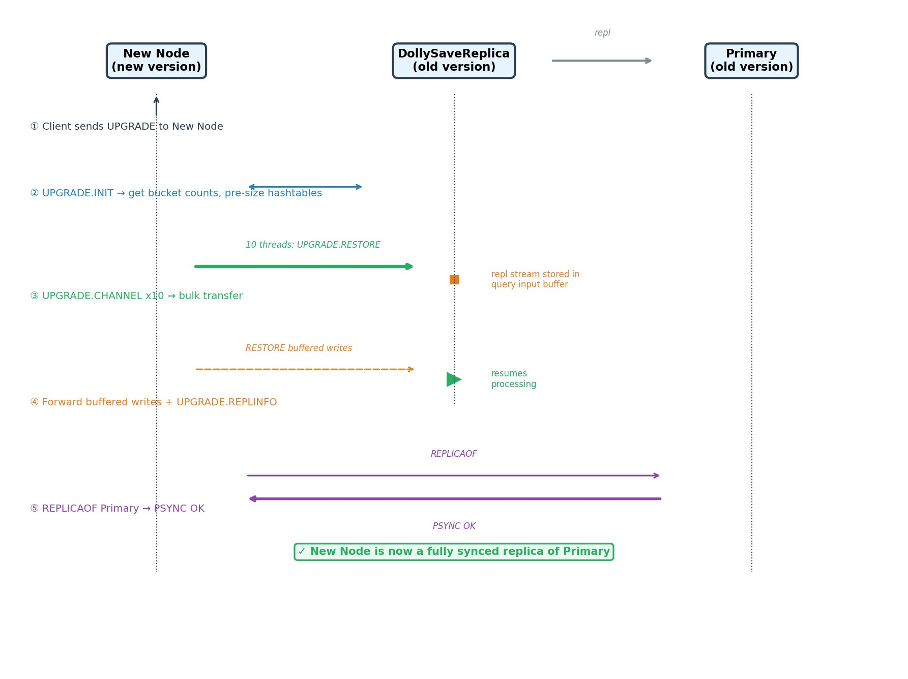

Code: https://github.com/asafpamzn/valkey/commit/80985b14c

Appendix B: DollySave — Earlier COW-Based Design (Deprecated)

An earlier DollySave prototype implemented copy-on-write tracking in userspace: when the process wrote to a page during transfer, the kernel intercepted the write via userfaultfd write-protect, copied the original page content first, then allowed the write to proceed — mirroring how fork-based BGSAVE works but without the fork. This approach (documented in the detailed design and high-level design) had some advantages: it required only Linux kernel 5.7 and produced a point-in-time consistent snapshot without any freeze window during bulk transfer. However, under high write workloads the COW page-copy overhead caused the same latency pattern we see with BGSAVE— elevated p50/p99 for the first 30–50 seconds as criu copies pages on every write fault. The current DollySave design avoids this by using dirty-page tracking (PAGEMAP_SCAN) instead of write-protect faults: writes proceed unimpeded, and dirty pages are simply re-sent in subsequent iterations. The trade-off is a brief final freeze (233 ms – 1.95 s) to capture the last dirty pages, but zero latency impact during the bulk transfer phase.

Appendix C: Value size at the fleet
Average Value Size — All Valkey Instances, No Size Filter (us-east-1, last 24h): 250,617 Valkey instances (all versions with valkey_version set), avg 11.3 GB memory, ~14M keys per instance.
 | A | B | C
1 | percentile | avg_value_size_bytes | human_readable
2 | p1 | 138 | 138 B
3 | p2 | 172 | 172 B
4 | p3 | 206 | 206 B
5 | p4 | 233 | 233 B
6 | p5 | 257 | 257 B
7 | p10 | 420 | 420 B
8 | p20 | 956 | ~1 KB
9 | p30 | 2132 | ~2.1 KB
10 | p40 | 4360 | ~4.3 KB
11 | p50 | 13222 | ~12.9 KB
12 | p60 | 45971 | ~44.9 KB
13 | p70 | 252252 | ~246 KB
14 | p80 | 1613620 | ~1.5 MB
15 | p90 | 9677972 | ~9.2 MB
16 | p95 | 25572709 | ~24.4 MB
17 | p99 | 70035721 | ~66.8 MB
18 | max | 34361065580 | ~34.4 GB
19 | mean | 8238487 | ~8.2 MB
The formula is simply used_memory / total_keys — this gives you the average bytes per key including Valkey's internal
overhead (~70-100 bytes per key for the dict entry + key object). The actual user payload per value is smaller.

Appendix C1: Appendix C query
-- =============================================================================
-- Average Value Size Percentiles — All Valkey Instances (no filter)
-- =============================================================================
--
-- OUTPUT FILE: valkey_avg_value_size_percentiles.csv
--
-- DESCRIPTION:
-- This query computes the average value size (used_memory / total_keys) per
-- instance, then calculates percentiles across all Valkey instances in us-east-1.
--
-- The formula used_memory / total_keys gives the average bytes per key INCLUDING
-- Valkey's internal per-key overhead (~70-100 bytes for dict entry + key object).
-- The actual user data payload per value is smaller than this number.
--
-- A value can be a string, hash table, sorted set, list, or set. This metric
-- is the average across all data types on the instance.
--
-- FILTERS:
-- - valkey_version IS NOT NULL and != '' and != '0' (Valkey instances only)
-- - total_keys > 0 (exclude empty instances)
-- - No memory utilization filter
--
-- RESULTS (us-east-1, last 24h, 258,611 instances):
-- P1: 138 B | P2: 172 B | P3: 206 B | P4: 233 B | P5: 257 B
-- P10: 424 B | P20: 966 B | P30: 2,199 B | P40: 4,264 B | P50: 12,738 B
-- P60: 45,971 B | P70: 252,252 B | P80: 1.6 MB | P90: 9.7 MB | P99: 70 MB
--
-- KEY SIZE REDUCTION ANALYSIS:
-- If we reduce per-key overhead by 32 bytes (e.g., Valkey 8.1/8.2 optimization):
-- savings% = 32 / avg_value_size × 100
--
-- P3 (206 bytes): 15.5% savings ← only ~3% of fleet saves 15%+
-- P5 (257 bytes): 12.5% savings
-- P10 (424 bytes): 7.5% savings
-- P50 (12,738 bytes): 0.25% savings ← median instance barely benefits
--
-- DATA SOURCE:
-- Database: AwsDataCatalog.logs_metrics_db_us_east_1
-- Tables: optimized_time_series_metrics, optimized_cross_sectional_metrics
-- Access: isengard get 730498392616 AnalyticsViewer
-- =============================================================================
WITH instance_avg AS (
SELECT
ts.instance,
AVG(CAST(ts.used_memory AS DOUBLE) / NULLIF(ts.total_keys, 0)) as avg_value_size_bytes
FROM "AwsDataCatalog"."logs_metrics_db_us_east_1"."optimized_time_series_metrics" ts
JOIN "AwsDataCatalog"."logs_metrics_db_us_east_1"."optimized_cross_sectional_metrics" cs
ON ts.datehour = cs.datehour AND ts.instance = cs.instance AND ts.customer = cs.customer
WHERE ts.datehour >= date_format(date_add('day', -1, current_date), '%Y/%m/%d/%H')
AND ts.datehour < date_format(current_date, '%Y/%m/%d/%H')
AND cs.datehour >= date_format(date_add('day', -1, current_date), '%Y/%m/%d/%H')
AND cs.datehour < date_format(current_date, '%Y/%m/%d/%H')
AND ts.total_keys > 0
AND cs.valkey_version IS NOT NULL AND cs.valkey_version != '' AND cs.valkey_version != '0'
GROUP BY ts.instance
)
SELECT
COUNT(*) as instance_count,
ROUND(APPROX_PERCENTILE(avg_value_size_bytes, 0.01), 0) as p1,
ROUND(APPROX_PERCENTILE(avg_value_size_bytes, 0.02), 0) as p2,
ROUND(APPROX_PERCENTILE(avg_value_size_bytes, 0.03), 0) as p3,
ROUND(APPROX_PERCENTILE(avg_value_size_bytes, 0.04), 0) as p4,
ROUND(APPROX_PERCENTILE(avg_value_size_bytes, 0.05), 0) as p5,
ROUND(APPROX_PERCENTILE(avg_value_size_bytes, 0.10), 0) as p10,
ROUND(APPROX_PERCENTILE(avg_value_size_bytes, 0.20), 0) as p20,
ROUND(APPROX_PERCENTILE(avg_value_size_bytes, 0.30), 0) as p30,
ROUND(APPROX_PERCENTILE(avg_value_size_bytes, 0.40), 0) as p40,
ROUND(APPROX_PERCENTILE(avg_value_size_bytes, 0.50), 0) as p50,
ROUND(APPROX_PERCENTILE(avg_value_size_bytes, 0.60), 0) as p60,
ROUND(APPROX_PERCENTILE(avg_value_size_bytes, 0.70), 0) as p70,
ROUND(APPROX_PERCENTILE(avg_value_size_bytes, 0.80), 0) as p80,
ROUND(APPROX_PERCENTILE(avg_value_size_bytes, 0.90), 0) as p90,
ROUND(APPROX_PERCENTILE(avg_value_size_bytes, 0.95), 0) as p95,
ROUND(APPROX_PERCENTILE(avg_value_size_bytes, 0.99), 0) as p99,
ROUND(MIN(avg_value_size_bytes), 0) as min_bytes,
ROUND(MAX(avg_value_size_bytes), 0) as max_bytes,
ROUND(AVG(avg_value_size_bytes), 0) as mean_bytes
FROM instance_avg

Appendix D: Save operational issues
This query measures how many BGSAVE/Threadsave/Dual-channel save operations were attempted and how many succeeded on Valkey 8+ instances over a 30-days window in us-east-1.

Other key findings:
- 96% of all failures come from just 142 instances. One single instance alone accounts for 11,090 failures (35% of all failures fleet-wide).
- P50 and P90 attempts per instance = 1 — the vast majority of instances attempt threadsave once and succeed
- Only 739 out of 19,739 instances (3.7%) ever fail
- Those 739 failing instances also used fork (278 of them), with 322 fork attempts and 49 fork failures (15% fork failure rate on the SAME instances)

Conclusion:
The metric is misleading because a few instances retry hundreds/thousands of times, inflating the failure count while the vast majority succeed on the first try.
 | A | B | C | D | E | F | G | H
1 | strategy | target | purpose | attempts | success | failures | failure_rate_pct | description
2 | fork | disk | snapshot | 1162307 | 1161931 | 376 | 0 | Standard BGSAVE backup to disk (fork child writes RDB file)
3 | fork | disk | sync | 333 | 315 | 18 | 5.4 | Replica requested full sync - primary forked and wrote RDB to disk then transferred. Replica received it.
4 | fork | socket | sync | 29901 | 29564 | 337 | 1.1 | Replica requested full sync - primary forked and streamed RDB over socket. Replica received it.
5 | thread | disk | snapshot | 33179 | 33169 | 10 | 0 | Threadsave backup to disk (used when memory too high to fork safely)
6 | thread | disk | sync | 34730 | 32609 | 2121 | 6.1 | Replica requested full sync - primary used threadsave to disk then transferred. Replica received it.
7 | thread | socket | sync | 51967 | 21578 | 30389 | 58.5 | Replica requested full sync - primary used threadsave streaming over socket. Replica FAILED to receive ‚Äî likely timed out waiting for slow threadsave.
8 | SYNC SOCKET TOTAL |  |  | 81868 | 51142 | 30726 | 37.53115
9 | SNAPSHOT TOTAL |  |  | 1195486 | 1195100 | 386 | 0 | All backup/snapshot operations combined
10 | SYNC TOTAL |  |  | 116931 | 84066 | 32865 | 28.1 | All full-sync replication operations (replica side only)
11 | GRAND TOTAL |  |  | 1312417 | 1279166 | 33251 | 2.5 | All save operations

Appendix D1: Appendix D query
-- =============================================================================
-- Valkey 8+ Save Strategy Success/Failure Rates
-- =============================================================================
--
-- OUTPUT FILE: valkey8_save_strategy_30days.csv
--
-- DESCRIPTION:
-- This query measures how many BGSAVE/Threadsave/Dual-channel save operations
-- were attempted and how many succeeded on Valkey 8+ instances over a 30-day
-- window in us-east-1.
--
-- The output table has one row per strategy combination:
-- strategy x target x purpose x trigger
--
-- Each row shows:
-- - attempts: how many save operations of this type started
-- - success: how many completed successfully
-- - failures: how many failed (attempts - success)
-- - failure_rate_pct: percentage of failures
--
-- WHAT THE STRATEGIES MEAN:
-- fork = fork() creates a child process that serializes data.
-- Parent continues serving. OS shares memory via COW (copy-on-write).
-- Fast but uses up to 2x memory if writes happen during save.
--
-- thread = Background thread on same process serializes data.
-- Objects are cloned then queued. No fork, no COW memory overhead.
-- Slower than fork because it cooperates with main thread for CPU.
-- Used when memory is too high to safely fork.
--
-- dual-channel = Two parallel network streams transfer data to replica.
-- Newest mechanism, very low adoption so far.
--
-- WHAT THE TARGETS MEAN:
-- disk = Writes RDB file to local disk (then transfers to replica or keeps as backup)
-- socket = Streams RDB directly over network to replica (diskless, avoids disk I/O)
--
-- WHAT THE PURPOSES MEAN:
-- snapshot = Point-in-time backup (customer-initiated, scheduled, or scaling event)
-- sync = Full replication (complete data transfer from primary to replica)
--
-- WHAT THE TRIGGERS MEAN:
-- scheduled/on-demand = Customer backup or auto-snapshot. No replication involved.
-- primary (sync-primary / EVENT_SYNC_MASTER):
-- Metric recorded on the PRIMARY node. Tracks the save operation
-- (bgsave/threadsave) that the primary runs to generate the RDB for replication.
-- The replica always initiates the sync (PSYNC), but this counter tracks
-- the primary's perspective: "I ran a save to serve a full-sync request."
-- replica (sync-replica / EVENT_SYNC_SLAVE):
-- Metric recorded on the REPLICA node. Tracks whether the replica
-- successfully received and loaded the RDB from the primary.
-- Same logical sync event as sync-primary, just the other side.
--
-- IMPORTANT: Both events are about the SAME replication sync, observed from
-- different nodes. The replica always initiates (PSYNC). The primary generates
-- the RDB. Both sides independently track success/failure.
--
-- So "thread_socket_sync_replica 60.5% failure" means: replicas are failing
-- to receive/load the RDB that was streamed via threadsave. The primary may
-- have completed its threadsave successfully, but the replica timed out or
-- disconnected before the transfer finished.
--
-- METHODOLOGY:
-- The amz_strategy counters are ACCUMULATIVE - they increment over the lifetime
-- of the Redis/Valkey process and never reset (except on restart).
-- To get actual event counts in a time window:
-- 1. Group by instance
-- 2. Compute MAX(counter) - MIN(counter) per instance = delta (actual events)
-- 3. SUM all deltas across instances = fleet total
--
-- Using SUM() directly on these counters would be WRONG because each instance's
-- counter is sampled hourly, so a counter value of 100 would be counted 24 times/day
-- (once per hourly data point), giving 2400 instead of the real delta.
--
-- DATA SOURCE:
-- Database: AwsDataCatalog.logs_metrics_db_us_east_1
-- Tables:
-- - optimized_time_series_metrics (has the strategy counters, 1 row per instance per hour)
-- - optimized_cross_sectional_metrics (has valkey_version, joined to filter)
-- Partition key: datehour (format: %Y/%m/%d/%H)
-- Access: isengard get 730498392616 AnalyticsViewer
--
-- KEY FINDING:
-- thread + socket + sync + replica-triggered has 60.5% failure rate on Valkey 8+.
-- This single combination accounts for 84% of all sync failures.
-- Improves across versions: 81.4% (8.0.1) -> 54.3% (8.1.0) -> 33.8% (8.2.0) -> 12.1% (9.0.0)
-- =============================================================================
SELECT
engine_version,
SUM(fork_disk_snapshot_att) as fork_disk_snapshot_attempts,
SUM(fork_disk_snapshot_suc) as fork_disk_snapshot_success,
SUM(fork_disk_sync_primary_att) as fork_disk_sync_primary_attempts,
SUM(fork_disk_sync_primary_suc) as fork_disk_sync_primary_success,
SUM(fork_disk_sync_replica_att) as fork_disk_sync_replica_attempts,
SUM(fork_disk_sync_replica_suc) as fork_disk_sync_replica_success,
SUM(fork_socket_sync_primary_att) as fork_socket_sync_primary_attempts,
SUM(fork_socket_sync_primary_suc) as fork_socket_sync_primary_success,
SUM(fork_socket_sync_replica_att) as fork_socket_sync_replica_attempts,
SUM(fork_socket_sync_replica_suc) as fork_socket_sync_replica_success,
SUM(thread_disk_snapshot_att) as thread_disk_snapshot_attempts,
SUM(thread_disk_snapshot_suc) as thread_disk_snapshot_success,
SUM(thread_disk_sync_primary_att) as thread_disk_sync_primary_attempts,
SUM(thread_disk_sync_primary_suc) as thread_disk_sync_primary_success,
SUM(thread_disk_sync_replica_att) as thread_disk_sync_replica_attempts,
SUM(thread_disk_sync_replica_suc) as thread_disk_sync_replica_success,
SUM(thread_socket_sync_primary_att) as thread_socket_sync_primary_attempts,
SUM(thread_socket_sync_primary_suc) as thread_socket_sync_primary_success,
SUM(thread_socket_sync_replica_att) as thread_socket_sync_replica_attempts,
SUM(thread_socket_sync_replica_suc) as thread_socket_sync_replica_success,
SUM(dc_socket_sync_primary_att) as dc_socket_sync_primary_attempts,
SUM(dc_socket_sync_primary_suc) as dc_socket_sync_primary_success,
COUNT(*) as instance_count
FROM (
SELECT
CASE
WHEN cs.valkey_version IN ('8.0.1','8.1.0','8.2.0','9.0.0')
THEN 'valkey_' || cs.valkey_version
ELSE 'other'
END as engine_version,
ts.instance as instance,
MAX("amz_strategy.fork.disk.snapshot.attempts.count") - MIN("amz_strategy.fork.disk.snapshot.attempts.count") as fork_disk_snapshot_att,
MAX("amz_strategy.fork.disk.snapshot.success.count") - MIN("amz_strategy.fork.disk.snapshot.success.count") as fork_disk_snapshot_suc,
MAX("amz_strategy.fork.disk.sync-primary.attempts.count") - MIN("amz_strategy.fork.disk.sync-primary.attempts.count") as fork_disk_sync_primary_att,
MAX("amz_strategy.fork.disk.sync-primary.success.count") - MIN("amz_strategy.fork.disk.sync-primary.success.count") as fork_disk_sync_primary_suc,
MAX("amz_strategy.fork.disk.sync-replica.attempts.count") - MIN("amz_strategy.fork.disk.sync-replica.attempts.count") as fork_disk_sync_replica_att,
MAX("amz_strategy.fork.disk.sync-replica.success.count") - MIN("amz_strategy.fork.disk.sync-replica.success.count") as fork_disk_sync_replica_suc,
MAX("amz_strategy.fork.socket.sync-primary.attempts.count") - MIN("amz_strategy.fork.socket.sync-primary.attempts.count") as fork_socket_sync_primary_att,
MAX("amz_strategy.fork.socket.sync-primary.success.count") - MIN("amz_strategy.fork.socket.sync-primary.success.count") as fork_socket_sync_primary_suc,
MAX("amz_strategy.fork.socket.sync-replica.attempts.count") - MIN("amz_strategy.fork.socket.sync-replica.attempts.count") as fork_socket_sync_replica_att,
MAX("amz_strategy.fork.socket.sync-replica.success.count") - MIN("amz_strategy.fork.socket.sync-replica.success.count") as fork_socket_sync_replica_suc,
MAX("amz_strategy.thread.disk.snapshot.attempts.count") - MIN("amz_strategy.thread.disk.snapshot.attempts.count") as thread_disk_snapshot_att,
MAX("amz_strategy.thread.disk.snapshot.success.count") - MIN("amz_strategy.thread.disk.snapshot.success.count") as thread_disk_snapshot_suc,
MAX("amz_strategy.thread.disk.sync-primary.attempts.count") - MIN("amz_strategy.thread.disk.sync-primary.attempts.count") as thread_disk_sync_primary_att,
MAX("amz_strategy.thread.disk.sync-primary.success.count") - MIN("amz_strategy.thread.disk.sync-primary.success.count") as thread_disk_sync_primary_suc,
MAX("amz_strategy.thread.disk.sync-replica.attempts.count") - MIN("amz_strategy.thread.disk.sync-replica.attempts.count") as thread_disk_sync_replica_att,
MAX("amz_strategy.thread.disk.sync-replica.success.count") - MIN("amz_strategy.thread.disk.sync-replica.success.count") as thread_disk_sync_replica_suc,
MAX("amz_strategy.thread.socket.sync-primary.attempts.count") - MIN("amz_strategy.thread.socket.sync-primary.attempts.count") as thread_socket_sync_primary_att,
MAX("amz_strategy.thread.socket.sync-primary.success.count") - MIN("amz_strategy.thread.socket.sync-primary.success.count") as thread_socket_sync_primary_suc,
MAX("amz_strategy.thread.socket.sync-replica.attempts.count") - MIN("amz_strategy.thread.socket.sync-replica.attempts.count") as thread_socket_sync_replica_att,
MAX("amz_strategy.thread.socket.sync-replica.success.count") - MIN("amz_strategy.thread.socket.sync-replica.success.count") as thread_socket_sync_replica_suc,
MAX("amz_strategy.dual-channel.socket.sync-primary.attempts.count") - MIN("amz_strategy.dual-channel.socket.sync-primary.attempts.count") as dc_socket_sync_primary_att,
MAX("amz_strategy.dual-channel.socket.sync-primary.success.count") - MIN("amz_strategy.dual-channel.socket.sync-primary.success.count") as dc_socket_sync_primary_suc
FROM "AwsDataCatalog"."logs_metrics_db_us_east_1"."optimized_time_series_metrics" ts
JOIN "AwsDataCatalog"."logs_metrics_db_us_east_1"."optimized_cross_sectional_metrics" cs
ON ts.datehour = cs.datehour AND ts.instance = cs.instance AND ts.customer = cs.customer
WHERE ts.datehour >= date_format(date_add('day', -30, current_date), '%Y/%m/%d/%H')
AND ts.datehour < date_format(current_date, '%Y/%m/%d/%H')
AND cs.datehour >= date_format(date_add('day', -30, current_date), '%Y/%m/%d/%H')
AND cs.datehour < date_format(current_date, '%Y/%m/%d/%H')
AND cs.valkey_version IN ('8.0.1','8.1.0','8.2.0','9.0.0')
GROUP BY ts.instance,
CASE
WHEN cs.valkey_version IN ('8.0.1','8.1.0','8.2.0','9.0.0')
THEN 'valkey_' || cs.valkey_version
ELSE 'other'
END
)
GROUP BY engine_version
ORDER BY instance_count DESC

Appendix E: Why 10% of memory should become the new default for reserved memory?
When reserving memory we are concern about 2 factors, frag ratio and the output buffers at the replicas. The following analysis shows that we can make 10% the new default for reserved memory as:

- The frag ratio at the fleet for instances with high memory usage is low, for 80% of the instances in us-east-1 with 80% memory usage 11% of memory for fragmentation is enough and for 70% 7.9% will be enough. See table below.
- The output buffers on replicas are negligible for reservation purposes, even at P99 worst-case, less than 1% of maxmemory is needed

The following table depicts the mem_fragmentation_ratio (process_rss / used_memory) for instances that are actually memory-constrained (using >= 80% of their maxmemory). This filters out over-provisioned instances where the ratio is
artificially inflated by small used_memory relative to process baseline RSS.
 | A | B | C
1 | metric | value | description
2 | p10_mem_frag_ratio | 0.931 | 10th percentile
3 | p20_mem_frag_ratio | 1.001 | 20th percentile
4 | p30_mem_frag_ratio | 1.019 | 30th percentile
5 | p40_mem_frag_ratio | 1.03 | 40th percentile
6 | p50_mem_frag_ratio | 1.044 | 50th percentile (median), 4.4% extra memory needed
7 | p60_mem_frag_ratio | 1.058 | 60th percentile
8 | p70_mem_frag_ratio | 1.079 | 70th percentile
9 | p80_mem_frag_ratio | 1.109 | 80th percentile ‚ 10.9% extra memory needed
10 | p90_mem_frag_ratio | 1.159 | 90th percentile ‚ 15.9% extra memory needed
11 | p95_mem_frag_ratio | 1.207 | 95th percentile ‚ 20.7% extra memory needed
12 | p99_mem_frag_ratio | 1.419 | 99th percentile ‚ 41.9% extra memory needed
What about replicas output buffers?
We measured the output buffer overhead on REPLICA nodes that are memory-constrained (using >= 80% of maxmemory). The goal is to understand how much memory to reserve for client output buffers on replicas. We found out:
- Output buffers on replicas are negligible for reservation purposes.
- Even at P99 worst-case, less than 1% of maxmemory is needed.
 | A | B
1 | metric | largest_normal_output_buffer × connected_clients as % of maxmemory
2 | P50 | ~0%
3 | P80 | 0.01%
4 | P90 | 0.14%
5 | P95 | 0.26%
6 | P99 | 0.84%
METRICS USED:
- amz_client_largest_normal_output_buffer: Point-in-time snapshot of the single largest output buffer among all "normal" clients (read/write clients, excludes replicas/pubsub/proxy).
- connected_clients: Number of clients currently connected to this instance.

WHAT WE COMPUTE:
- -- largest_buffer × connected_clients = worst-case total output buffer memory. This is an OVERESTIMATE because it assumes every client has a buffer as large as the single largest one. In reality, most clients are idle with 0 bytes pending. Only one client has that peak buffer (e.g., running a large MGET or SCAN response).

Appendix E1: Appendix E queries
asafp@f4d488973bd7:~/work/valkey$ cat fragmentation_80pct_utilization.sql
-- =============================================================================
-- Memory Fragmentation Ratio for Instances Using >= 80% of maxmemory
-- =============================================================================
--
-- OUTPUT FILE: fragmentation_80pct_utilization.csv
--
-- DESCRIPTION:
-- This query measures the mem_fragmentation_ratio (process_rss / used_memory)
-- for instances that are actually memory-constrained (using >= 80% of their
-- maxmemory). This filters out over-provisioned instances where the ratio is
-- artificially inflated by small used_memory relative to process baseline RSS.
--
-- WHY THIS MATTERS:
-- mem_fragmentation_ratio tells you how much physical RAM the process uses
-- beyond the data it stores. The "extra" (ratio - 1) is what you need to
-- reserve for fragmentation overhead. If ratio = 1.1, you need 10% extra RAM.
--
-- WHY FILTER ON >= 80% UTILIZATION:
-- Only ~3% of the fleet (28,990 / 985,146 in us-east-1) uses >= 80% of
-- maxmemory. The other 97% are over-provisioned and show inflated ratios
-- (e.g., an instance with 100MB RSS and 30MB used_memory = ratio 3.3x,
-- but there's no real fragmentation — it's just baseline process overhead).
-- Filtering to memory-constrained instances shows the true fragmentation
-- that matters for reservation planning.
--
-- INCLUDES: All Redis versions (4.x through 7.x) and all Valkey versions
-- (7.2, 7.3, 8.x, 9.x) — no engine filter applied.
--
-- RESULTS (us-east-1, last 24h, 28,990 instances):
-- P50 (median): 1.044 → reserve 4.4% for fragmentation
-- P80: 1.109 → reserve 10.9% for fragmentation
-- P90: 1.159 → reserve 15.9% for fragmentation
-- P95: 1.207 → reserve 20.7% for fragmentation
--
-- CONCLUSION:
-- For memory-constrained instances, reserve 10-15% for fragmentation.
-- Combined with COW (fork-based BGSAVE): need 10-15% (frag) + 25% (COW) = 35-40%
-- Without COW (threadsave/live migration): need only 10-15% total.
--
-- DATA SOURCE:
-- Database: AwsDataCatalog.logs_metrics_db_us_east_1
-- Tables: optimized_time_series_metrics, optimized_cross_sectional_metrics
-- Access: isengard get 730498392616 AnalyticsViewer
-- =============================================================================
-- Query 1: Fragmentation percentiles for instances >= 80% utilized
WITH instance_frag AS (
SELECT
ts.instance,
AVG(ts.mem_fragmentation_ratio) as avg_frag_ratio,
AVG(ts.allocator_frag_ratio) as avg_allocator_frag_ratio,
AVG(CAST(ts.used_memory AS DOUBLE) / NULLIF(cs.maxmemory, 0)) as avg_memory_pct
FROM "AwsDataCatalog"."logs_metrics_db_us_east_1"."optimized_time_series_metrics" ts
JOIN "AwsDataCatalog"."logs_metrics_db_us_east_1"."optimized_cross_sectional_metrics" cs
ON ts.datehour = cs.datehour AND ts.instance = cs.instance AND ts.customer = cs.customer
WHERE ts.datehour >= date_format(date_add('day', -1, current_date), '%Y/%m/%d/%H')
AND ts.datehour < date_format(current_date, '%Y/%m/%d/%H')
AND cs.datehour >= date_format(date_add('day', -1, current_date), '%Y/%m/%d/%H')
AND cs.datehour < date_format(current_date, '%Y/%m/%d/%H')
AND ts.mem_fragmentation_ratio > 0
AND cs.maxmemory > 0
GROUP BY ts.instance
HAVING AVG(CAST(ts.used_memory AS DOUBLE) / NULLIF(cs.maxmemory, 0)) >= 0.80
)
SELECT
COUNT(*) as instance_count,
ROUND(AVG(avg_memory_pct), 3) as avg_memory_utilization,
ROUND(AVG(avg_frag_ratio), 3) as mean_mem_frag,
ROUND(APPROX_PERCENTILE(avg_frag_ratio, 0.10), 3) as p10,
ROUND(APPROX_PERCENTILE(avg_frag_ratio, 0.20), 3) as p20,
ROUND(APPROX_PERCENTILE(avg_frag_ratio, 0.30), 3) as p30,
ROUND(APPROX_PERCENTILE(avg_frag_ratio, 0.40), 3) as p40,
ROUND(APPROX_PERCENTILE(avg_frag_ratio, 0.50), 3) as p50,
ROUND(APPROX_PERCENTILE(avg_frag_ratio, 0.60), 3) as p60,
ROUND(APPROX_PERCENTILE(avg_frag_ratio, 0.70), 3) as p70,
ROUND(APPROX_PERCENTILE(avg_frag_ratio, 0.80), 3) as p80,
ROUND(APPROX_PERCENTILE(avg_frag_ratio, 0.90), 3) as p90,
ROUND(APPROX_PERCENTILE(avg_frag_ratio, 0.95), 3) as p95,
ROUND(APPROX_PERCENTILE(avg_frag_ratio, 0.99), 3) as p99
FROM instance_frag;
-- Query 2: Count total instances vs instances >= 80% utilized
SELECT
COUNT(*) as total_instances,
COUNT(CASE WHEN avg_pct >= 0.80 THEN 1 END) as instances_above_80pct,
ROUND(COUNT(CASE WHEN avg_pct >= 0.80 THEN 1 END) * 100.0 / COUNT(*), 1) as pct_above_80
FROM (
SELECT
ts.instance,
AVG(CAST(ts.used_memory AS DOUBLE) / NULLIF(cs.maxmemory, 0)) as avg_pct
FROM "AwsDataCatalog"."logs_metrics_db_us_east_1"."optimized_time_series_metrics" ts
JOIN "AwsDataCatalog"."logs_metrics_db_us_east_1"."optimized_cross_sectional_metrics" cs
ON ts.datehour = cs.datehour AND ts.instance = cs.instance AND ts.customer = cs.customer
WHERE ts.datehour >= date_format(date_add('day', -1, current_date), '%Y/%m/%d/%H')
AND ts.datehour < date_format(current_date, '%Y/%m/%d/%H')
AND cs.datehour >= date_format(date_add('day', -1, current_date), '%Y/%m/%d/%H')
AND cs.datehour < date_format(current_date, '%Y/%m/%d/%H')
AND cs.maxmemory > 0
AND ts.mem_fragmentation_ratio > 0
GROUP BY ts.instance
);
-- =============================================================================
-- Replica Output Buffer Analysis
-- =============================================================================
--
-- OUTPUT FILE: replica_output_buffer_analysis.csv
--
-- DESCRIPTION:
-- This query measures the output buffer overhead on REPLICA nodes that are
-- memory-constrained (using >= 80% of maxmemory). The goal is to understand
-- how much memory to reserve for client output buffers on replicas.
--
-- WHAT IS AN OUTPUT BUFFER:
-- When a client sends a command (e.g., GET, MGET, SCAN), the server prepares
-- the response in an output buffer before sending it over the network. If the
-- client is slow to read, or the response is large, this buffer grows.
-- Each connected client has its own output buffer.
--
-- METRICS USED:
-- amz_client_largest_normal_output_buffer:
-- Point-in-time snapshot of the single largest output buffer among all
-- "normal" clients (read/write clients, excludes replicas/pubsub/proxy).
-- Computed by iterating all clients when INFO is called.
-- NOT a peak or rolling window — just the biggest one right now.
--
-- connected_clients:
-- Number of clients currently connected to this instance.
--
-- WHAT WE COMPUTE:
-- largest_buffer × connected_clients = worst-case total output buffer memory
-- This is an OVERESTIMATE because it assumes every client has a buffer as
-- large as the single largest one. In reality, most clients are idle with
-- 0 bytes pending. Only one client has that peak buffer (e.g., running a
-- large MGET or SCAN response).
--
-- The actual total output buffer memory is tracked by mem_clients_normal
-- in INFO Memory, but that metric is not available in the datalake.
--
-- FILTERS:
-- - role = 'replica' (only replica nodes, not primaries)
-- - used_memory / maxmemory >= 0.80 (only memory-constrained instances)
-- - All Redis + Valkey versions included
--
-- RESULTS (us-east-1, last 24h, 13,762 replicas, avg 58 GB maxmemory):
--
-- Largest single output buffer:
-- P50: 259 bytes | P90: 26 KB | P99: 1.2 MB
--
-- Worst-case total (largest_buffer × clients) as % of maxmemory:
-- P50: 0% | P80: 0.013% | P90: 0.14% | P95: 0.26% | P99: 0.84%
--
-- CONCLUSION:
-- Output buffers on replicas are negligible for reservation purposes.
-- Even at P99 worst-case, less than 1% of maxmemory is needed.
-- The mean (56%) is meaningless — dragged up by extreme outliers where
-- one client has a 70 GB buffer (likely stuck MONITOR or huge KEYS response).
--
-- DATA SOURCE:
-- Database: AwsDataCatalog.logs_metrics_db_us_east_1
-- Tables: optimized_time_series_metrics, optimized_cross_sectional_metrics
-- Access: isengard get 730498392616 AnalyticsViewer
-- =============================================================================
WITH replica_data AS (
SELECT
ts.instance,
AVG(ts.used_memory) as avg_used_memory,
MAX(cs.maxmemory) as maxmemory,
AVG(ts.connected_clients) as avg_connected_clients,
AVG(ts.amz_client_largest_normal_output_buffer) as avg_largest_normal_ob,
MAX(ts.amz_client_largest_normal_output_buffer) as max_largest_normal_ob,
AVG(ts.amz_client_largest_normal_output_buffer * ts.connected_clients) as avg_total_ob_estimate,
AVG(CAST(ts.amz_client_largest_normal_output_buffer AS DOUBLE) * ts.connected_clients / NULLIF(cs.maxmemory, 0) * 100) as avg_ob_pct_maxmem
FROM "AwsDataCatalog"."logs_metrics_db_us_east_1"."optimized_time_series_metrics" ts
JOIN "AwsDataCatalog"."logs_metrics_db_us_east_1"."optimized_cross_sectional_metrics" cs
ON ts.datehour = cs.datehour AND ts.instance = cs.instance AND ts.customer = cs.customer
WHERE ts.datehour >= date_format(date_add('day', -1, current_date), '%Y/%m/%d/%H')
AND ts.datehour < date_format(current_date, '%Y/%m/%d/%H')
AND cs.datehour >= date_format(date_add('day', -1, current_date), '%Y/%m/%d/%H')
AND cs.datehour < date_format(current_date, '%Y/%m/%d/%H')
AND cs.role = 'replica'
AND cs.maxmemory > 0
GROUP BY ts.instance
HAVING AVG(CAST(ts.used_memory AS DOUBLE) / NULLIF(cs.maxmemory, 0)) >= 0.80
)
SELECT
COUNT(*) as replica_count,
-- Connected clients
ROUND(AVG(avg_connected_clients), 1) as avg_clients,
ROUND(APPROX_PERCENTILE(avg_connected_clients, 0.50), 0) as p50_clients,
ROUND(APPROX_PERCENTILE(avg_connected_clients, 0.90), 0) as p90_clients,
ROUND(APPROX_PERCENTILE(avg_connected_clients, 0.99), 0) as p99_clients,
ROUND(MAX(avg_connected_clients), 0) as max_clients,
-- Largest single normal output buffer (absolute bytes)
ROUND(AVG(avg_largest_normal_ob), 0) as mean_normal_ob_bytes,
ROUND(APPROX_PERCENTILE(avg_largest_normal_ob, 0.50), 0) as p50_normal_ob_bytes,
ROUND(APPROX_PERCENTILE(avg_largest_normal_ob, 0.80), 0) as p80_normal_ob_bytes,
ROUND(APPROX_PERCENTILE(avg_largest_normal_ob, 0.90), 0) as p90_normal_ob_bytes,
ROUND(APPROX_PERCENTILE(avg_largest_normal_ob, 0.95), 0) as p95_normal_ob_bytes,
ROUND(APPROX_PERCENTILE(avg_largest_normal_ob, 0.99), 0) as p99_normal_ob_bytes,
ROUND(MAX(max_largest_normal_ob), 0) as max_normal_ob_bytes,
-- Total OB estimate (largest_buffer × clients) absolute bytes
ROUND(AVG(avg_total_ob_estimate), 0) as mean_total_ob_estimate_bytes,
ROUND(APPROX_PERCENTILE(avg_total_ob_estimate, 0.50), 0) as p50_total_ob_bytes,
ROUND(APPROX_PERCENTILE(avg_total_ob_estimate, 0.80), 0) as p80_total_ob_bytes,
ROUND(APPROX_PERCENTILE(avg_total_ob_estimate, 0.90), 0) as p90_total_ob_bytes,
ROUND(APPROX_PERCENTILE(avg_total_ob_estimate, 0.95), 0) as p95_total_ob_bytes,
ROUND(APPROX_PERCENTILE(avg_total_ob_estimate, 0.99), 0) as p99_total_ob_bytes,
-- Total OB as % of maxmemory
ROUND(AVG(avg_ob_pct_maxmem), 4) as mean_ob_pct_maxmem,
ROUND(APPROX_PERCENTILE(avg_ob_pct_maxmem, 0.50), 4) as p50_ob_pct_maxmem,
ROUND(APPROX_PERCENTILE(avg_ob_pct_maxmem, 0.80), 4) as p80_ob_pct_maxmem,
ROUND(APPROX_PERCENTILE(avg_ob_pct_maxmem, 0.90), 4) as p90_ob_pct_maxmem,
ROUND(APPROX_PERCENTILE(avg_ob_pct_maxmem, 0.95), 4) as p95_ob_pct_maxmem,
ROUND(APPROX_PERCENTILE(avg_ob_pct_maxmem, 0.99), 4) as p99_ob_pct_maxmem,
-- Context
ROUND(AVG(maxmemory) / 1073741824, 2) as avg_maxmemory_gb
FROM replica_data

Appendix F: Replication related sev2s in ElastiCache
From 2025/05/01 to 2026/05/01, replication issues make up 7.01% of ElastiCache data plane sev2s for Provisioned and 1.09% for Serverless. Swapping issues makes up another 1.45% for Provisioned.
 | A | B | C | D | E | F
1 |  | Total # of sev2s | Replication -  Full-sync/COB/Throttling |  | Swap
2 | Provisioned | 6617(link) | 464 (link) | 7.01% | 96 (link) | 1.45%
3 | Serverless | 1558 (link) | 17 (link) | 1.09% | 0 | 0.00%

